After visualizing MNIST using t-SNE we can see that it can’t interpret cluster size and intercluster distances.

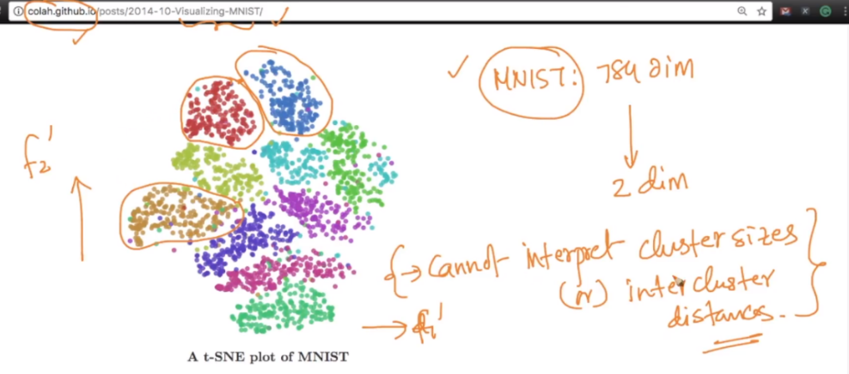

t-SNE while grouping, also group those together which have same visual similarity, example orange cluster is of 1, but the marked small cluster(in left) in orange is of slant shape of 1 (/) and a cluster in orange is right is of straight 1, that means while grouping, the intergrouping also done on basis of visual similarity.

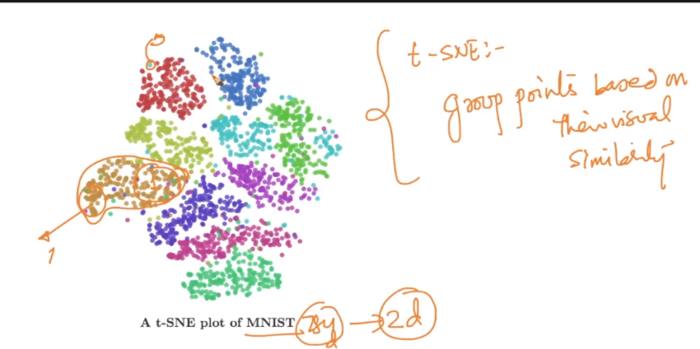

**what algorithm is used to solve the mnist test dataset?**

Assuming you are asking about the classification of the mnist data set. you can apply any classification algorithms like knn, SVM etc  
Assuming you are asking about the dimensionality reduction of the mnist data set. you can apply PCA on both train and test data  
Assuming you are asking about the visualization of the mnist data set. you can apply TSNE on both train and test data